Sahil Saini Salaria

Roll Noi 11C

Reg No 180905048

Practice 1

Server:
import socket

# host=socket.gethostname()

HOST = '127.0.0.1'
PORT = 2053

with socket.socket(socket.AF_INET, socket.SOCK_STREAM) as s:
s.bind((HOST,PORT))
s.listen(5)
conn,addr=s.accept()
print("Hi")

with conn:
print("Connected by :",addr)
while True:
data=conn.recv(1024)
if data:
print("From client got:",data.decode())
data=input("Enter msg to client:")

if not data:
break

conn.sendall(bytearray(data,'utf-8'))

print("Hello")

conn.close()

Client

import socket

HOST='127.0.0.1'
PORT=2053

with socket.socket(socket.AF_INET,socket.SOCK_STREAM) as s:
s.connect((HOST,PORT))
data=input("send data to server:")
s.sendall(bytearray(data,'utf-8'))
data=s.recv(1024)
print("From Server Got back")
print(data.decode())

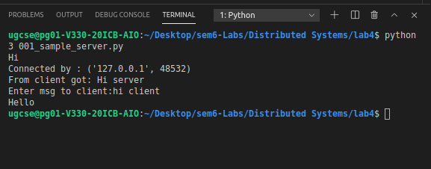

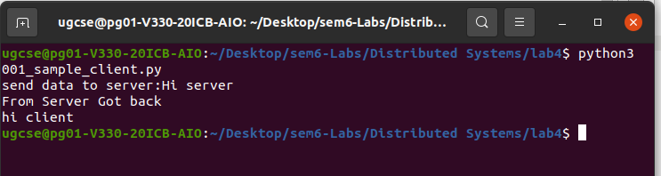

Practice 2

Server

import socket
import time

serversoc=socket.socket(socket.AF_INET,socket.SOCK_STREAM)

host=socket.gethostname()

port=9992

serversoc.bind((host,port))

serversoc.listen(5)

while True:
conn,addr=serversoc.accept()

print("Got connection from :",addr[0],addr[1])
currentTime=time.ctime(time.time())

conn.send(currentTime.encode('ascii'))
conn.close()
serversoc.close()

Client

import socket
s=socket.socket(socket.AF_INET,socket.SOCK_STREAM)
host=socket.gethostname()
port=9992

s.connect((host,port))

tm=s.recv(1024)

print("Current time from server:",tm.decode())

s.close()

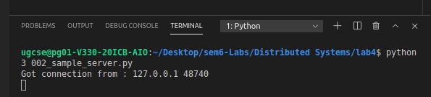

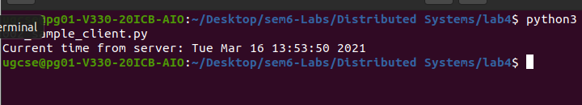

Practice 3

Client

import socket
s=socket.socket(socket.AF_INET,socket.SOCK_STREAM)
host=socket.gethostname()
port=9991

s.connect((host,port))

while True:
print("Client:",end=' ')
data=str(input())
temp=data
s.sendall(bytearray(data,'utf-8'))
if temp.lower()=='bye':
break

data=s.recv(1024)
print("Server:",data.decode())
if data.decode().lower()=='bye':
break

s.close()

Server
import socket
import time

serversoc=socket.socket(socket.AF_INET,socket.SOCK_STREAM)

host=socket.gethostname()

port=9991

serversoc.bind((host,port))

serversoc.listen(5)

conn,addr=serversoc.accept()

while True:

data=conn.recv(1024)

if data:
print("Client: ",data.decode())
if data.decode().lower()=='bye':
break

print("Server:",end=' ')
send_data=str(input())

conn.sendall(bytearray(send_data,'utf-8'))

if send_data.lower()=='bye':
break

serversoc.close()

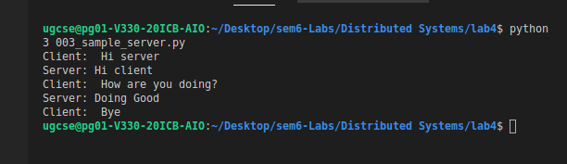
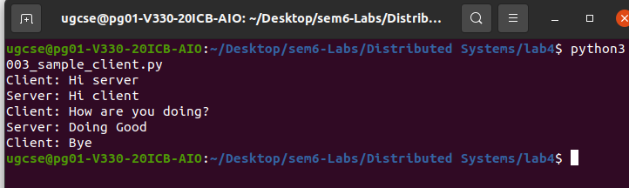

Practice 4

Server

import socket
import os
from _thread import *

ServerSocket = socket.socket()

host = '127.0.0.1'
port = 11596

ThreadCount = 0

try:
ServerSocket.bind((host, port))
except socket.error as e:
print(str(e))

print('Waitiing for a Connection..')
ServerSocket.listen(5)

def threaded_client(connection):
connection.send(str.encode('Welcome to the Server'))
while True:
data = connection.recv(2048)
print('Received from client :' + str(ThreadCount) +data.decode())
Inputs = input('Server Says: ')
if not data:
break
connection.sendall(Inputs.encode())
connection.close()

while True:
Client, address = ServerSocket.accept()
print('Connected to: ' + address[0] + ':' + str(address[1]))
start_new_thread(threaded_client, (Client, ))
ThreadCount += 1
print('Thread Number: ' + str(ThreadCount))
ServerSocket.close()

Client 1

import socket

ClientSocket = socket.socket()

host = '127.0.0.1'
port = 11596

print('Waiting for connection')

try:
ClientSocket.connect((host, port))
except socket.error as e:
print(str(e))

Response = ClientSocket.recv(1024)

while True:
Input = input('Client Say Something: ')
ClientSocket.send(str.encode(Input))
Response = ClientSocket.recv(1024)
print('From Server : ' + Response.decode())
ClientSocket.close()

Client 2

import socket

ClientSocket = socket.socket()

host = '127.0.0.1'
port = 11596

print('Waiting for connection')

try:
ClientSocket.connect((host, port))
except socket.error as e:
print(str(e))

Response = ClientSocket.recv(1024)

while True:
Input = input('Client Say Something: ')
ClientSocket.send(str.encode(Input))
Response = ClientSocket.recv(1024)
print('From Server : ' + Response.decode())
ClientSocket.close()

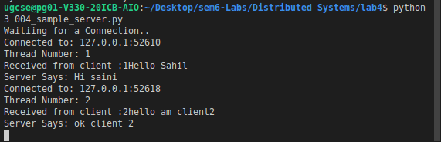

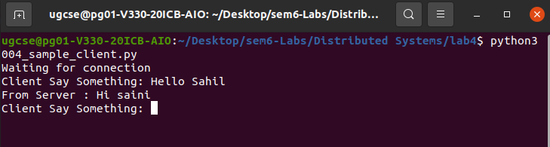

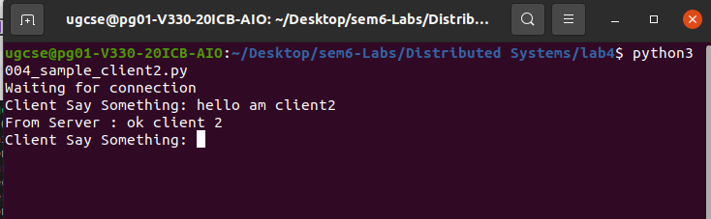

EXERCISE

Question 1:

Server
import socket
import time

serversoc=socket.socket(socket.AF_INET,socket.SOCK_DGRAM)

host=socket.gethostname()
port=9992

serversoc.bind((host,port))

while True:

data_got=serversoc.recvfrom(1024)
address=data_got[1]
currentTime=time.ctime(time.time())

serversoc.sendto(currentTime.encode('ascii'),address)

serversoc.close()

Client

import socket

s=socket.socket(socket.AF_INET,socket.SOCK_STREAM)
host=socket.gethostname()
port=9992

address=(host,port)

s.sendto(bytearray("Hi there",'utf-8'),address)
tm=s.recvfrom(1024)
print("Current time from server:",tm.decode())

s.close()

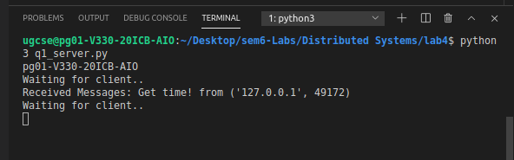

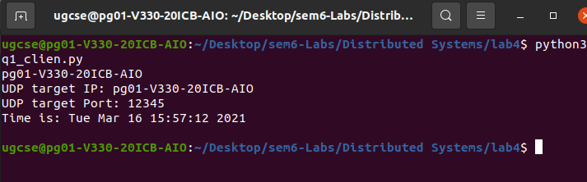

Question2

Server

import socket as skt
import time
sock = skt.socket(skt.AF_INET, skt.SOCK_DGRAM)

udp_host = skt.gethostname()
udp_port = 12345

sock.bind((udp_host, udp_port))
print('Waiting for client')
data, addr = sock.recvfrom(1024)
msg = 'Server'
sock.sendto(msg.encode(), addr)
name = data.decode()
while True:
data, addr = sock.recvfrom(1024)
if data.decode() == 'exit':
print(name, ' has exited')
else:
print(name, ": ", data.decode())
msg = input('Me: ')

sock.sendto(msg.encode(), addr)
if msg == 'exit':
break

Client

import socket as skt

sock = skt.socket(skt.AF_INET, skt.SOCK_DGRAM)

udp_host = skt.gethostname()
print(udp_host)
udp_port = 12345
msg = "Hello brother"
print('Target UDP host {}\nTarget UDP port {}'.format(str(udp_host), str(udp_port)))

msg = 'Client'
sock.sendto(msg.encode(), (udp_host, udp_port))
data, addr = sock.recvfrom(1024)
name = data.decode()

while True:
msg = input('Me: ')
sock.sendto(msg.encode(), (udp_host, udp_port))
if msg == 'exit':
break
data, addr = sock.recvfrom(1024)
if data.decode() == 'exit':
print(name, ' has exited')
else:
print(name, ": ", data.decode())

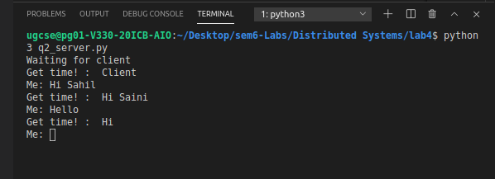

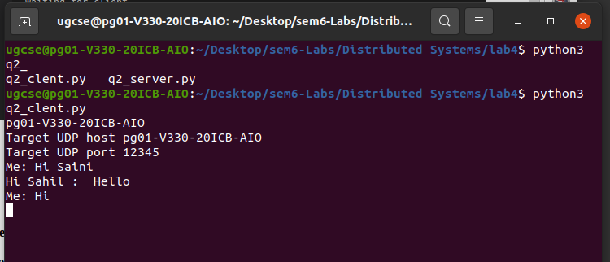

Question 3:

Server

import socket

HOST = '172.16.58.54'
PORT = 2003
s = socket.socket()
s.bind((HOST, PORT))
s.listen()

print("\nWaiting for incoming connections...\n")

conn, addr = s.accept()

print("Received connection from ", addr[0], "(", addr[1], ")\n")

s_name = conn.recv(1024)
s_name = s_name.decode()

print(s_name, "has connected to the chat room\nEnter [e] to exit chat room\n")
name = input(str("Enter your name: "))
conn.send(name.encode())

while True:
message = input(str("Me : "))
if message == "[e]":
message = "Left chat room!"
conn.send(message.encode())
print("\n")
break
conn.send(message.encode())
message = conn.recv(1024)
message = message.decode()
print(s_name, ":", message)

Client

import socket
HOST = '172.16.58.54'
PORT = 2003
s = socket.socket()
name = input(str("\nEnter your name: "))
s.connect((HOST, PORT))
s.send(name.encode())
s_name = s.recv(1024)
s_name = s_name.decode()
print(s_name, "has joined the chat room\nEnter E to exit chat room\n")
while True:
message = s.recv(1024)
message = message.decode()
print(s_name, ":", message)
message = input(str("Me : "))
if message == "E":
message = "Left chat room!"
s.send(message.encode())
print("\n")
break
s.send(message.encode())

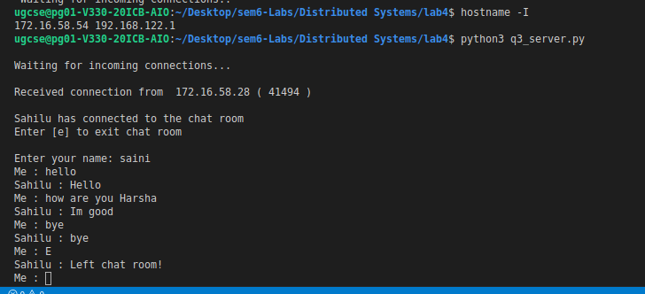

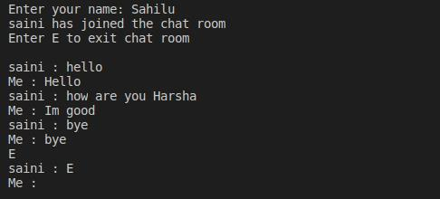

/////////////////////////////////////////ENDS///////////////////////////////////////////

